6.3 LEFT OUTER JOIN, RIGHT OUTER JOIN AND INNER JOIN
LEFT OUTER JOIN
SELECT E.EMP_ID, E.EMP_NAME, E.DEP_ID, D.DEP_NAME
FROM EMPLOYEES E
LEFT OUTER JOIN DEP1 D
ON E.DEP_ID = D.DEP_ID;
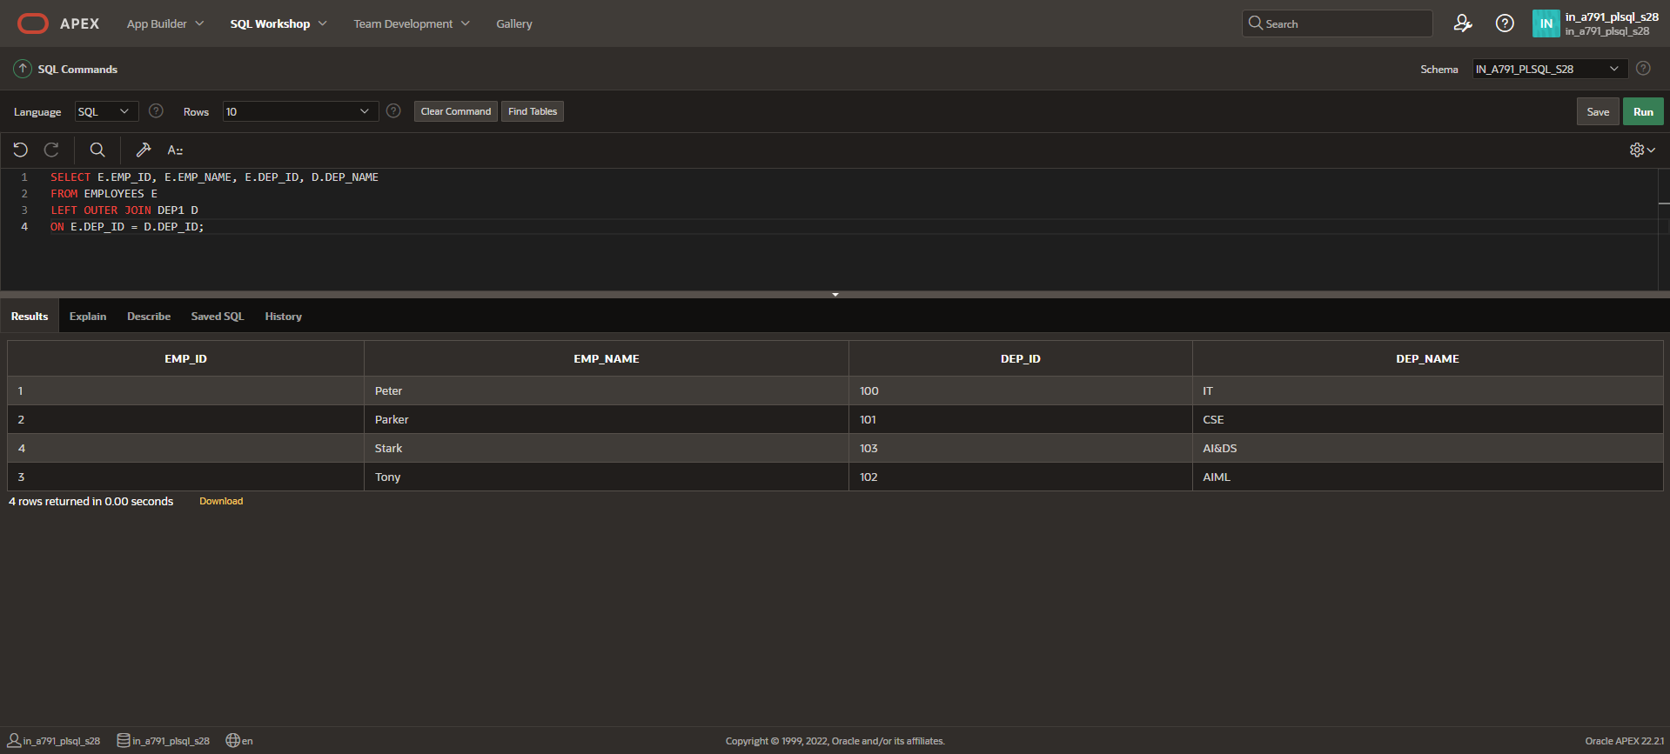
RIGHT OUTER JOIN
SELECT E.EMP_ID, E.EMP_NAME, E.DEP_ID, D.DEP_NAME
FROM EMPLOYEES E
RIGHT OUTER JOIN DEP1 D
ON E.DEP_ID = D.DEP_ID;
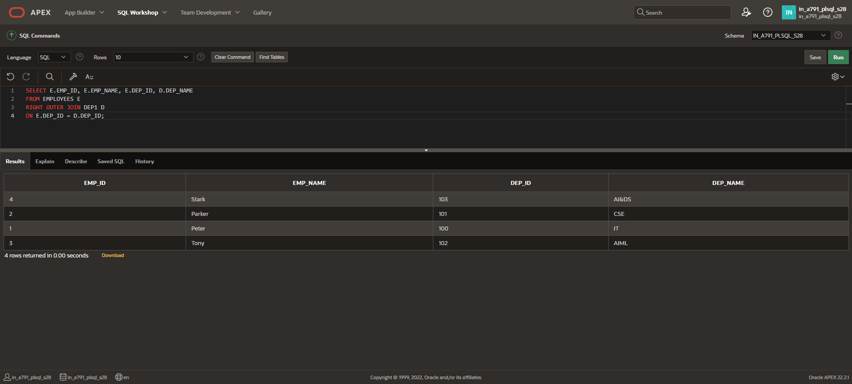
INNER JOIN
SELECT E.EMP_ID, E.EMP_NAME, E.DEP_ID, D.DEP_NAME
FROM EMPLOYEES E
INNER JOIN DEP1 D
ON E.DEP_ID = D.DEP_ID;
